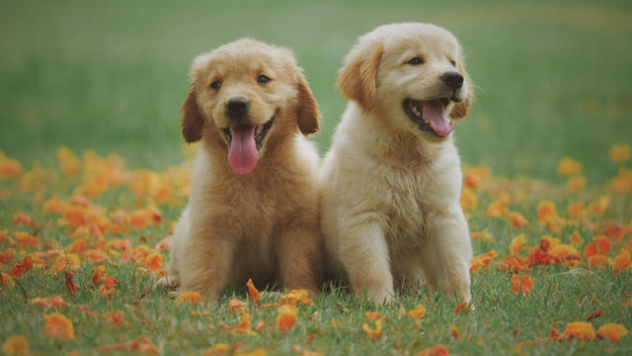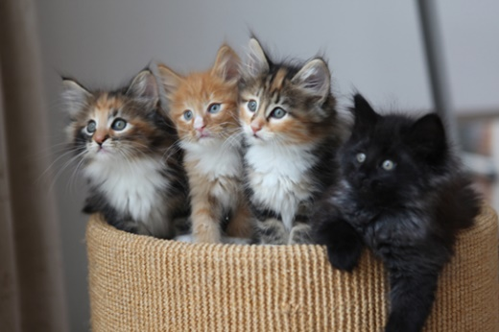
Marine City Maritime Days Pet Photo Contest!
So, you think you have the cutest pet? Then enter them into the Maritime Days Pet Photo contest! The winning pet photo will win $100…
Here is how it works:
Submit three (3) copies of your favorite photo of your pet! We will collect photos through May 23, 2021. At that time, the Maritime Days Board will randomly select 30 finalists. Those 30 finalists will be placed on display at one of our local businesses for you to vote, vote, vote! Check back for voting locations! Voting will run through July 30, 2021. Votes cost 25 cents! Winners will be announced Friday, August 6, 2021 at 6:00pm before the crowning of Miss Maritime Days!
Before you submit a photo of your pet below, PLEASE follow these guidelines
- Choose one favorite photo and submit three (3) copies of it just once. Make sure they are good quality photos. Blurry photos will not be accepted. Photos must be no larger than 4x6.
- Include your Pets name, address, phone number and owners name on back of photos.
- Mail to: Marine City Festival, Cutest Pet Contest, PO Box 192, Marine City, MI 48039

*Submission Rules
- NOTE: All photos submitted to Maritime Days Festival will become property of Maritime Days Festival. Upon submission, you grant Maritime Days Festival the right to use the photo(s) in all forms of media, including throughout any of our publications (printed, online, or otherwise.)
- We accept photographs sent in color or black & white. Photos cannot be photoshopped.
- Pet Parent/legal guardian warrants that the photo submitted is original and not previously published, and that the Pet parent/legal guardian owns the copyright in such photo.
- VOTING: Voting boxes will be displayed at a local business once the finalists have been chosen and will remain there until July 30, 2021. Voting closes on July 30, 2021.
- Voting locations will be announced on this page once the finalists have been chosen.
- Pet must be present to collect prize for promotional photos.

