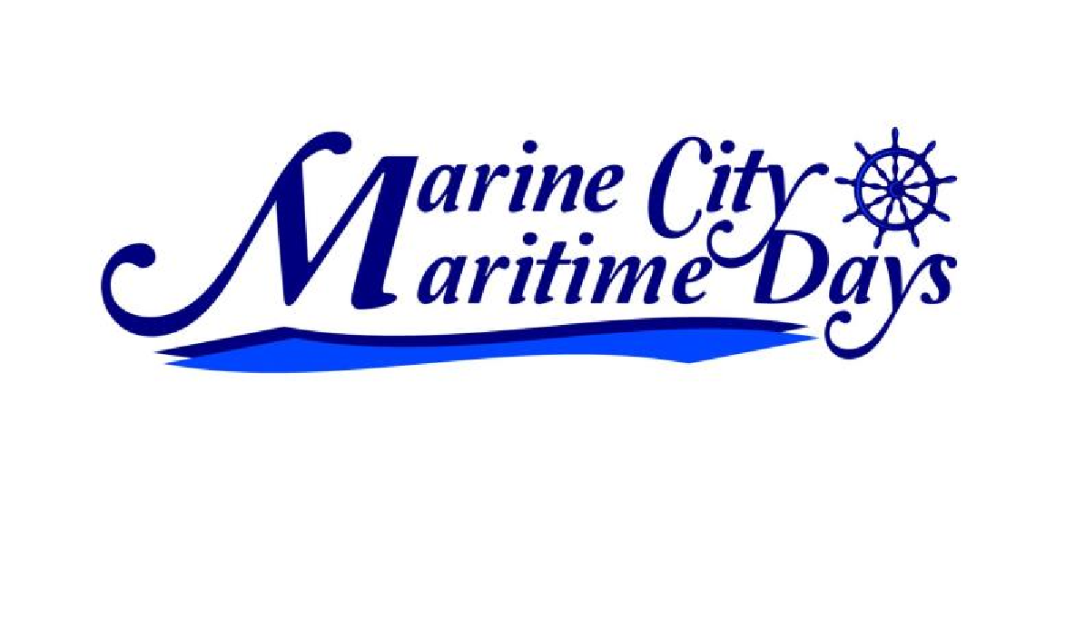
Marine City Festival Inc

PO Box 192, Marine City, MI 48039

Email: maritimedays@yahoo.com

Website:

www.MaritimeDays.net

August 6th, 7th & 8th, 2021

Juried Arts & Crafts Fair 2021
Saturday, August 7^{th,} 10 am – 6 pm and Sunday, August 8th, 10 am – 5 pm

Name: ________
____________________________________________________________________________________

Address:_________________________________City:_________________________State:_________Zip:_____________

Email:_________________________________________________Phone: _________________________________

Web Site: _______________________________________________________________ _______________

Electricity required? Yes No Handicapped Parking? Yes No

Number of booths required (booth size 10’ x 10’, $40.00 fee per booth):__________ Category of original work:
___ Silk/Dried Flowers ___ Stained Glass ___ Sculpture/Pottery
___ Blown Glass ___ Decorated Clothing ___ Knit/Crocheted
___ Painting Watercolors/Oil ___ Candles/Soap ___ Other–Please Specify
___ Woodcrafts ___ Jewelry _________________

Description:_________________________________________________________________________________
(Attach additional page if necessary)
- Please include (1-2) photos of your work and (1) photo of your setup. Photos will be returned the weekend of the festival.
- This is a juried event. Only original arts & crafts will be allowed. No kits, commercial items or flea market wares. Each exhibitor will be checked prior to the show opening. Crafters that don’t meet these criteria are invited to join us as an event vendor. Please visit our website for additional information and forms.
- Security will be furnished during the hours the show is closed, but we will not be liable for losses or damages occurring on the grounds.
- Vendors can set up Friday (August 6th) from noon – 8 pm and Saturday (August 7th) from 7-10 am. The festival is outdoors, so please provide your own tent.
- Please return this registration form, photos and booth fee, payable to Marine City Festival Inc. Please mail to Chris Finsterwald, 421 S. Elizabeth St., Marine City, MI 48039. A confirmation will be mailed to you. Final details along with a Booth Number will be sent to you approximately One (1) week prior to the event.

If you have any questions, please call Chris Finsterwald at (810)765-4492 or Sarah Polio at (810)765-4696 or email Sarah at spolio@sbcglobal.net

EXHIBITOR’S SIGNATURE________________________________________ DATE__________________
I understand that Marine City Festival Inc., The Maritime Days Committee and the City of Marine City are not responsible for any losses or damages to work, personal injury or property damage, nor will I be a party to any legal action against them, and I further agree to hold them harmless. I also consent to use of my name, photos and biographical information in any promotional items.

